**USER INPUT SUM OF TWO NUMBER**

**IF /ELSE STATEMENTS**

#include <stdio.h>

int main()

{

int n1,n2;

printf("Enter Num 1 :\n");

scanf("%d", &n1);

printf("Enter Num 2\n");

scanf("%d", &n2);

int sum=n1+n2;

printf("Sum is = %d\n",sum);

if(sum>10){

printf("sum is greater than 10\nsum is = %d",sum);

}

else{

printf("sum is Less than 10 \nsum is = %d",sum);

}

return 0;

}

**OUTPUT**:

**SWITCH CASE**

int n1,n2;

printf("Enter Num 1 :\n");

scanf("%d", &n1);

printf("Enter Num 2\n");

scanf("%d", &n2);

int sum=n1+n2;

printf("Sum is = %d\n",sum);

printf("\n\n");

switch(sum) {

case 1 ... 10:

printf("The sum is between 2 and 10.\n");

break;

case 11 ... 20:

printf("The sum is between 11 and 20.\n");

break;

case 21 ... 30:

printf("The sum is between 21 and 30.\n");

break;

case 31 ... 40:

printf("The sum is between 31 and 40.\n");

break;

case 41 ... 50:

printf("The sum is between 41 and 50.\n");

break;

default:

printf("The sum is outside the range of 1 to 50.\n");

break;

}

return 0;

}

**OUTPUT:**

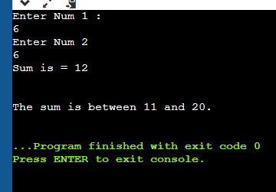

**Solution:**

int n1;

printf("Enter Nume a day NO (1-7):\n");

scanf("%d", &n1);

printf("\n");

switch(n1) {

case 1 :

printf("MONDAY\n");

break;

case 2:

printf("Tuesday\n");

break;

case 3:

printf("wednesday\n");

break;

case 4:

printf("thrusday\n");

break;

case 5:

printf("Friday\n");

break;

case 6:

printf("saturday\n");

break;

case 7:

printf("sunday\n");

break;

default:

printf("Invalid days.\n");

break;

}

return 0;

**OUTPUT**:

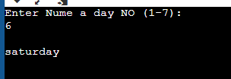

**FOR LOOPS**

**Printing number 1 to 10**

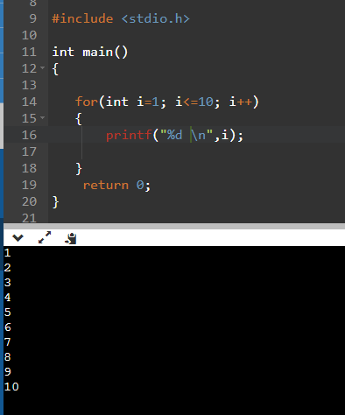

**EXPENSE OF WEEK**

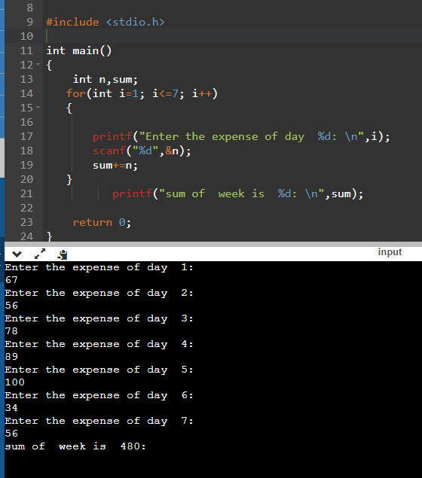

**DO WHILE LOOP**

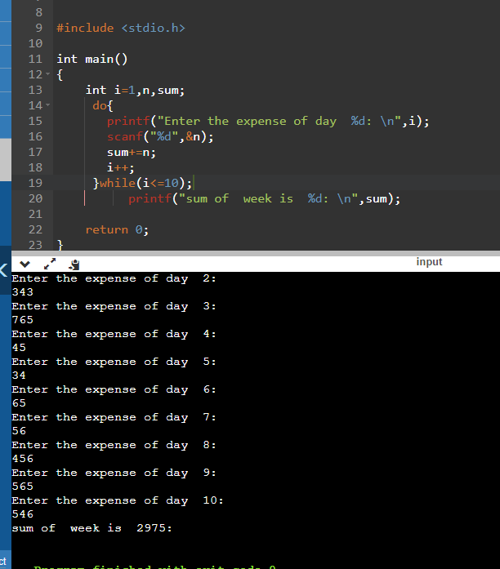

**WHILE LOOP**



